**Free Movie Nights**

**At 7:00 p.m.**

[](https://www.google.com/url?sa=i&rct=j&q=&esrc=s&source=images&cd=&cad=rja&uact=8&ved=2ahUKEwjhlJX18MTdAhUEON8KHXalDoYQjRx6BAgBEAU&url=https://www.thehut.com/blu-ray/the-greatest-showman-4k-ultra-hd/11640742.html&psig=AOvVaw1iBcZzpAgcXib9EqQQ0Nto&ust=1537371398132638)[](https://www.google.com/url?sa=i&rct=j&q=&esrc=s&source=images&cd=&cad=rja&uact=8&ved=2ahUKEwjO3aTFqcfdAhWyiOAKHbLoDT4QjRx6BAgBEAU&url=https://movies.disney.com/moana&psig=AOvVaw1jvhoRdatuEHunRaAPuVnG&ust=1537455319963560)[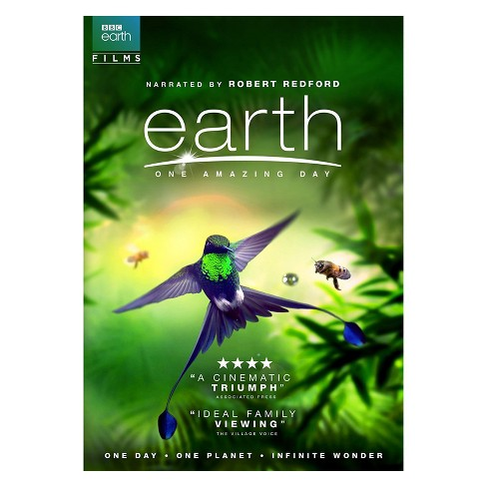](https://www.google.com/url?sa=i&rct=j&q=&esrc=s&source=images&cd=&cad=rja&uact=8&ved=2ahUKEwj2wubI98TdAhVPGt8KHc2IAAIQjRx6BAgBEAU&url=https://www.target.com/p/earth-one-amazing-day-dvd/-/A-53151646&psig=AOvVaw1Y05ZbbEbbw7xDkrBgtbGx&ust=1537373147060267)

**Sept. 28 Oct. 26 Nov. 30**

[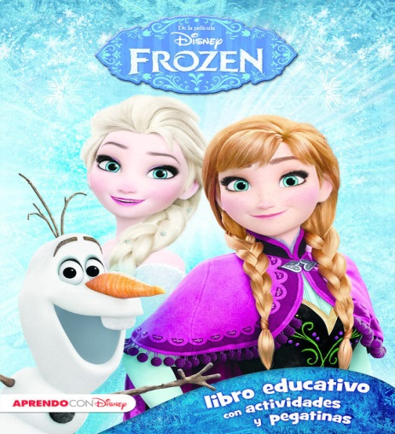](https://www.google.com/url?sa=i&rct=j&q=&esrc=s&source=images&cd=&cad=rja&uact=8&ved=2ahUKEwiUrZGnr8fdAhWNUt8KHQREB7gQjRx6BAgBEAU&url=https://www.casadellibro.com/libro-frozen-libro-educativo-disney-con-actividades-y-pegatinas/9788416548217/2739873&psig=AOvVaw0PYdw9DNwKE24euDYmdI-m&ust=1537456780166883)  [](https://www.google.com/url?sa=i&rct=j&q=&esrc=s&source=images&cd=&cad=rja&uact=8&ved=2ahUKEwj0s5Wf_MTdAhWhneAKHR2pCOwQjRx6BAgBEAU&url=https://www.pinterest.com/pin/29273466308361368/&psig=AOvVaw1jpgIFkVGK0soAA95oVLbn&ust=1537374433780034)

Nature

**Nantucket**

**Dec. 28 Jan. 25 Feb. 22**[](https://www.google.com/url?sa=i&rct=j&q=&esrc=s&source=images&cd=&cad=rja&uact=8&ved=2ahUKEwik78PP_MTdAhUkWN8KHZU8B20QjRx6BAgBEAU&url=https://www.celticnote.com/dvd/ccdvd1005&psig=AOvVaw0ubTgr5n6gjm75Fw6Mt2qg&ust=1537374533939496)

**Trinity United Church**

*“Growing in Christ, Sharing in Love”*

*A union of the Presbyterian Church USA and the United Church of Christ*

 118 King George Road

Warren, NJ 07059

(732) 469-5044

officetuc@gmail.com

www.trinityunitedchurch.org

Please join us!

**Mar. 22**